

PREPARATION NOTES

HTML

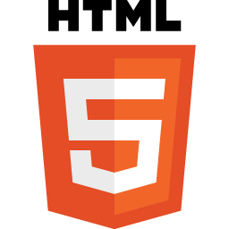

|  |
| --- |
| CONTENT  WHAT IS HTML?  TEXT EDITORS |